Ramesh,

I would like you to create a Tool for the www.starbreeder.org Admin Panel that will be used to create the Breeder’s Star Breeder Certificate web pages. .

Currently most of the Breeder’s Star Breeder HTML pages have #1 ranking on Google, Yahoo, and Bing search engines using the breeder’s name followed by “dog breede.r”. There is a formula we use to make this happen by incorporating a multifaceted array of elements into the web page, embedded URLs, backlinks, and organically generated hits. We must incorporate these different elements into the new ASPX pages as well.

Each of the Star Breeder Certificate pages must have the following elements when the new Tool creates the Breeder’s ASPX page::

- The Page URL must be customized to incorporate the Star Breeder’s Name or Kennel Name and sometimes the geographic location of the Breeder. (Note: All fonts shown in BOLD type are unique to the individual Star Breeder’s web page. All fonts shown in NORMAL type are common among all Star Breeder web pages. )
.
Example: http://www.starbreeder.org/certificate/Dwayne_Hurliman_Star_Dog_Breeder_Certificate.html

- The Page Title Name must be customized to the Star Breeder’s Name or Kennel Name and sometimes geographic location.

Example:
<title>Dwayne Hurliman Star Breeder Certificate</title>

- The Meta Tag Keywords are standard with customization to include the Breeder’s Name; City
and State; USDA License Number (if available); number of stars;

Example:
<meta content="Dwayne, Hurliman, dog, breeder, dwayne-hurliman, dog-breeder, cordell, ok, oklahoma. kennel, kennels, starbreeder, star breeder, 5-star, usda, puppymill, mill, puppy-mill, dog, law, puppy, puppies, ACA, inspected, inspection, report, 73-A-2621, 73a2661" name="Keywords" />

- The Meta Tag Description is standard with customization to include the Breeder’s Name; Number of stars; and sometimes City and State; USDA License Number (if available) (Note: All fonts shown in BOLD type are unique to the individual Star Breeder’s web page. All fonts shown in NORMAL type are common among all Star Breeder web pages. )

Example:
<meta content="Dwayne Hurliman fulfilled all requirements and earned a 5 star rating for 2014-15 by the American Canine Association, Inc. By completing all of the requirements outlined in the program, breeders earn up to five stars and are considered the finest. The American Canine Association strives to give breeders the tools they need to be the best. USDA No. 73-A-2621" name="Description" />

- Each Star Breeder web page has 12 images.

The most important image is the JPG of the Breeder’s Star Breeder Certificate.
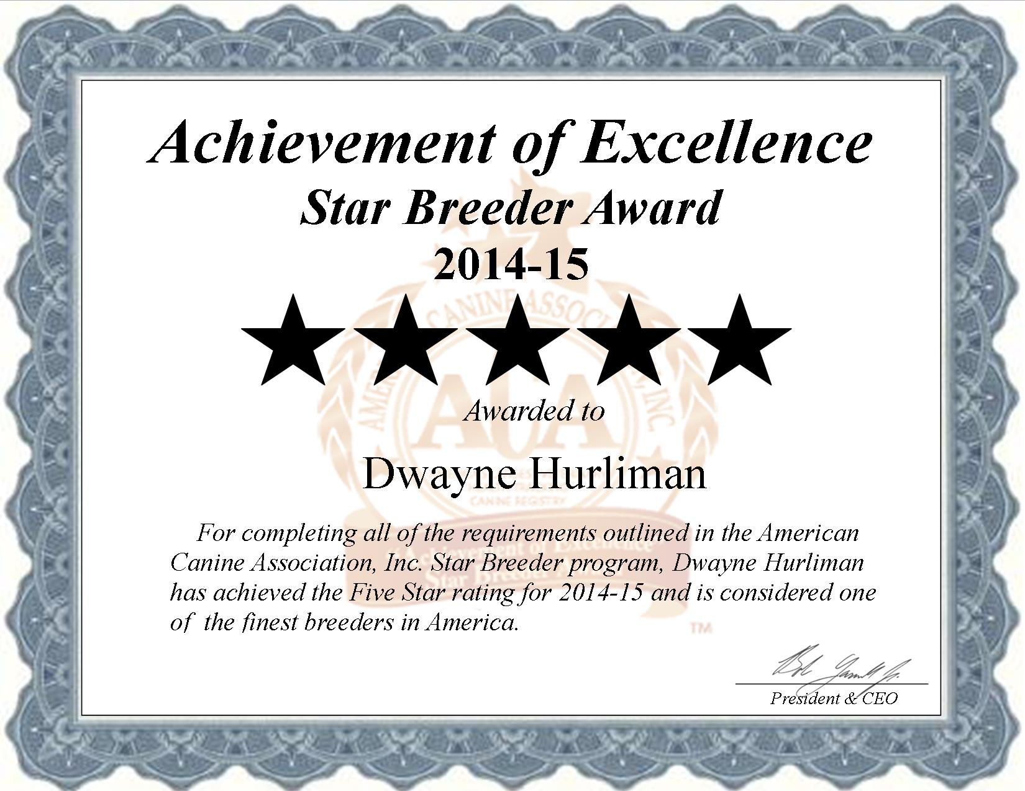

This image is intentionally placed at the uppermost top left-hand corner of the page and is very large in size. A hyperlink is also links to the Breeder’s Star Breeder Certificate image to to the Breeder’s Star Breeder Certificate PDF redirecting the User to the PDF when then commonly click on it..

Meta Tags are placed in the IMG ALT for SEO purpose within the web page and for image placement on Google Images and Yahoo Images. The Meta Tags are the same as the web page for the Star Breeder Certificate image with the addition of the word certificate.

Example:
<body leftmargin="0" topmargin="0">
<center><strong><a href="http://www.starbreeder.org/certificate/Dwayne_Hurliman_Star_Breeder_Certificate.pdf" pbzloc="2"><img alt="Dwayne, Hurliman, dog, breeder, dwayne-hurliman, dog-breeder, cordell, ok, oklahoma. kennel, kennels, starbreeder, star breeder, 5-star, USDA, puppymill, mill, puppy-mill, dog, law, puppy, puppies, ACA, usda, inspected , inspection report, 73-A-2621, 73a2661, certificate" height="1274" src="http://www.starbreeder.org/certificate/Dwayne_Hurliman_Star_Breeder_Certificate.jpg" style="height: 852px; width: 1066px" width="1650" /></a></strong></center>

The next three images are images of the Star Breeder Program. These images are also attached to this email. And should be incorporated into the new Star Breeder Certificate ASPX pages you are designing now. These are shown below:

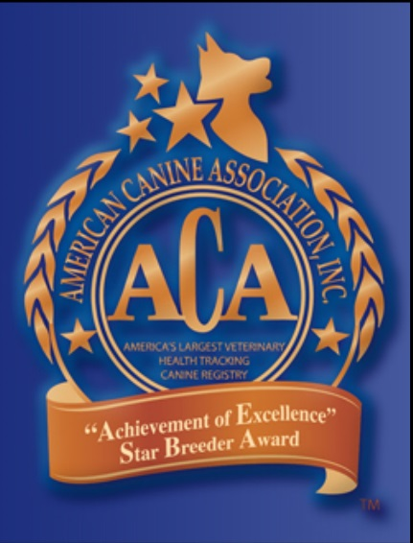

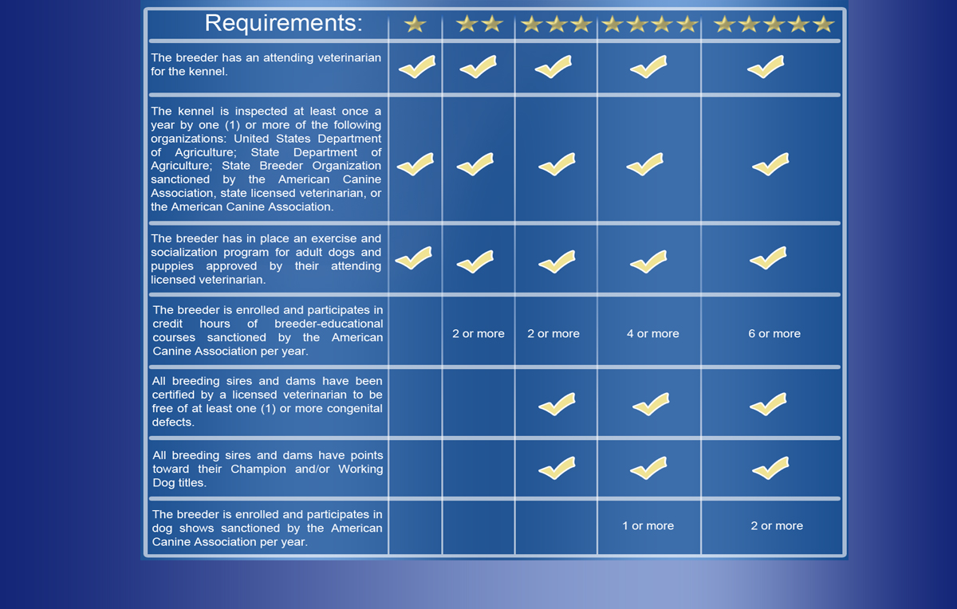

These images also have the same Meta Tag Keywords with the addition of an additional unique keyword such as logo, slogan, or requirements so that they are not exactly the same as each other

The balance of the images are Government sites ; colleges and universities; and veterinary sites. These normally differ slightly from Breeder to Breeder. For these images I would like the Admin User to choose up to eight images that have predetermined URLs . However, the ALT IMG text would be automatically generated by the Admin Tool in a similar method as the Star Breeder Certificate image ALT IMG text.

Example:
<p style="text-align: center"><span style="font-size: 9px"><a href="http://www.upenn.edu"><img alt="upenn, Dwayne, Hurliman, dog, breeder, dwayne-hurliman, dog-breeder, cordell, ok, oklahoma, kennel, kennels, starbreeder, star breeder, 5-star, USDA, puppymill, mill, puppy-mill, dog, law, puppy, puppies, ACA, usda, inspected, inspection, report, 73-A-2621, 73a2661, certificate" src="http://www.starbreeder.org/images/UnivPA.jpg" style="height: 45px; width: 124px" /></a>&nbsp; <a href="http://www.okstate.edu/"><img alt="" src="http://www.starbreeder.org/images/OKstate.jpg" style="height: 58px; width: 81px" /></a>&nbsp;&nbsp;</span><a href="http://www.offa.org"><img alt="ofa, Dwayne, Hurliman, dog, breeder, dwayne-hurliman, dog-breeder, cordell, ok, oklahoma, kennel, kennels, starbreeder, star breeder, 5-star, USDA, puppymill, mill, puppy-mill, dog, law, puppy, puppies, ACA, usda, inspected, inspection, report, 73-A-2621, 73a2661e" src="http://www.starbreeder.org/images/OFA.jpg" style="height: 58px; width: 58px" /></a><span style="font-size: 9px"> &nbsp;<a href="http://www.si.edu"><img alt="Smithsonian, Dwayne, Hurliman, dog, breeder, dwayne-hurliman, dog-breeder, cordell, ok, oklahoma, kennel, kennels, starbreeder, star breeder, 5-star, USDA, puppymill, mill, puppy-mill, dog, law, puppy, puppies, ACA, usda, inspected, inspection, report, 73-A-2621, 73a266" height="86" src="http://www.starbreeder.org/images/si.jpg" style="height: 59px; width: 97px" width="153" /></a>&nbsp; </span><a href="http://www.usda.gov"><strong><img alt="usda-logo, Dwayne, Hurliman, dog, breeder, dwayne-hurliman, dog-breeder, cordell, ok, oklahoma, kennel, kennels, starbreeder, star breeder, 5-star, USDA, puppymill, mill, puppy-mill, dog, law, puppy, puppies, ACA, usda, inspected, inspection, report, 73-A-2621, 73a2661" src="http://www.starbreeder.org/images/USDA.jpg" style="height: 57px; width: 88px" /></strong></a>&nbsp;<a href="http://www.oda.state.Mo.us/"><img alt="mo-state, Dwayne, Hurliman, dog, breeder, dwayne-hurliman, dog-breeder, cordell, ok, oklahoma, kennel, kennels, starbreeder, star breeder, 5-star, USDA, puppymill, mill, puppy-mill, dog, law, puppy, puppies, ACA, usda, inspected, inspection, report, 73-A-2621, 73a2661" src="http://www.starbreeder.org/images/OKdeptAg.jpg" style="height: 56px; width: 66px" /></a> <a href="http://www.senate.gov"><img alt="ok-ag-logo, Dwayne, Hurliman, dog, breeder, dwayne-hurliman, dog-breeder, cordell, ok, oklahoma, kennel, kennels, starbreeder, star breeder, 5-star, USDA, puppymill, mill, puppy-mill, dog, law, puppy, puppies, ACA, usda, inspected, inspection, report, 73-A-2621, 73a2661, certificate" src="http://www.starbreeder.org/images/USsenate.jpg" style="height: 56px; width: 59px" /></a>&nbsp;<a href="http://www.house.gov"><img alt="congress, Dwayne, Hurliman, dog, breeder, dwayne-hurliman, dog-breeder, cordell, ok, oklahoma, kennel, kennels, starbreeder, star breeder, 5-star, USDA, puppymill, mill, puppy-mill, dog, law, puppy, puppies, ACA, usda, inspected, inspection, report, 73-A-2621, 73a2661, certificate" src="http://www.starbreeder.org/images/UScongress.jpg" style="height: 55px; width: 57px" /></a></p>
.

- The next section is the TEXT section of the page detailing exactly what the Breeder has accomplished in meeting the requirements pertaining to each Star Level. Again SEO is used in this section with each item customized inserting the Breeder’s Name; in some areas their geographic location: and year.

Example:
Dwayne Hurliman passed all required USDA and Oklahoma inspections for 2014.
Dwayne Hurliman has an Oklahoma licensed attending veterinarian.
Dwayne Hurliman has in place daily socialization and exercise program, approved by the attending licensed veterinarian, for all of his adult dogs and puppies.
Dwayne Hurliman feeds all of his adult dogs and puppies only premium dog foods.
Dwayne Hurliman provides veterinary care, inoculations, dewormings, and proper grooming for all of his adult dogs and puppies.
All of Dwayne Hurliman’s breeding males and females have been certified free of one or more potential congenital defects by licensed veterinarians.
All of Dwayne Hurliman’s breeding males and females have two or more points towards the Championship titles.
Dwayne Hurliman has attended over 6 hours of ongoing breeder educational seminars for 2014.
Dwayne Hurliman has participated in 2 or more dog shows for 2014.
Dwayne Hurliman is a quality breeder specializing in toy breeds.
Dwayne Hurliman is a licensed and inspected breeding kennel is located in Cordell, OK.
Dwayne Hurliman has always exhibited exemplary care of their dogs and passed all required inspections and has never been charged with animal neglect or abuse.
Dwayne Hurliman USDA No. 73-A-2621.

- The next section is the before mentioned 8 images of Veterinary Educational Institutions, Governmental branches, and veterinary organizations. All are hyperlinked. These will generally differ from Breeder to Breeder depending on their geographic locations.

This section of the Admin Tool should ideally have a drop down selection box for the Amin User allowing the Admin User to select which of the eight images to be included. The image and it’s associated URL would be stored in a Table.

Example:

- The next section in Text information on many different canine health areas with SEO keywords inserted.

Example:

What is a Heart Murmur in Dogs?
Murmurs are extra heart vibrations that are produced as a result of a disturbance in the blood flow -- enough, in fact, to produce audible noise. Often, the murmurs are classified according to a variety of characteristics, including their timing. Systolic murmurs, for example, occur when the heart muscle contracts; diastolic murmurs occur when the heart muscle relaxes between beats; and continuous and to-and-fro murmurs occur throughout all or most of the cardiac cycle. Conscientious dog breeders will have their breeding stock certified free of this common congenital breeding defect found in many breeds of dogs.
Return the top of the page for Dwayne Hurliman, Cordell, Oklahoma - dog breeder information. Click here

- The next section is for SEO purposes using either the Breeder’s First Name or Last Name:

Example:
Related Searches of Similar Names
Dwayne Rollings dog breeder
Dwayne Henderson dog breeder
Dwayne Johnson dog breeder
Dwayne Fennelli dog breeder
Dwayne Schwartz dog breeder
Dwayne Rollty dog breeder
Dwayne Surelli dog breeder
Dwayne Swope dog breeder
Dwayne Jaworski dog breeder
Dwayne Andrez dog breeder
Dwayne Flintberg dog breeder
Russell Hulriman dog breeder
Susan Hulriman dog breeder
Sharon Hulriman dog breeder
Mark Hulriman dog breeder
Jamie Hulriman dog breeder
Lucynda Hulriman dog breeder
Merlie Hulriman dog breeder
Rhonda Hulriman dog breeder
Rochelle Hulriman dog breeder
Martha Hulriman dog breeder
Paul Hulriman dog breederr
10. Finally, I would like a bottom section added to all the Admin User to add LINKS similar to the Admin Tool for the State Breeder Associations (www.NYPPB.org)

